**Experiment No. 01**

* 1. **Experiment Name**

Introduction to MATLAB simulation

* 1. **Objectives**
* To learn about MATLAB tools and how they work
* To become acquainted with the Simulink platform and Simulink library
* To learn how to implement a system from an equation in the Simulink platform.
  1. **Theory**
     1. **Simulink**

Simulink is an application that allows you to simulate signals and dynamic systems. Simulink explores two stages: model definition and model analysis. It includes an interactive graphical environment and a collection of customizable block libraries that allow you to design, simulate, implement, and test a wide range of time-varying systems such as communications, controls, signal processing, video processing, and image processing.

Simulink contains toolboxes for developing, simulating, and analyzing communication systems. In addition, source coding, channel coding, interleaving, analog and digital modulation, equalization, synchronization, and channel modeling are all possible with Simulink.

* + 1. **Simulink Library**

The Simulink Library Browser is the library where you can locate all the Simulink blocks. Simulink software contains a large library of functions that are often used in system modeling. These are some examples:

* Commonly Used Blocks
* Continuous
* Discontinuous
* Discrete
* Logic and Bit Operation
* Lookup Tables
* Math Operation
* Model Verification
* Mode-Wide Utilities
* Port & Subsystem
* Signal Attributes
* Signal Routing
* Sinks
* Sources
* User defined Functions
* Additional Math & Discrete
  + 1. **Common Block Library**
* Math Operation
* Continuous
* Port & Subsystem
* Signal Routing
* Sink
* Sources
  1. **Apparatus**
* MATLAB Simulink
  1. **Implementation in Problem**

$S_{1}$ = $1\sin{ωt}$; f= 50hz

$S_{2}$ = Triangular signal; f= 500hz, Vp-p = 0 to 1

$S_{3}$ = Triangular signal; f= 500hz, Vp-p = -1 to 0

*Out1*=

*Out2* =

*Output*=

* 1. **Simulink Block Diagram**

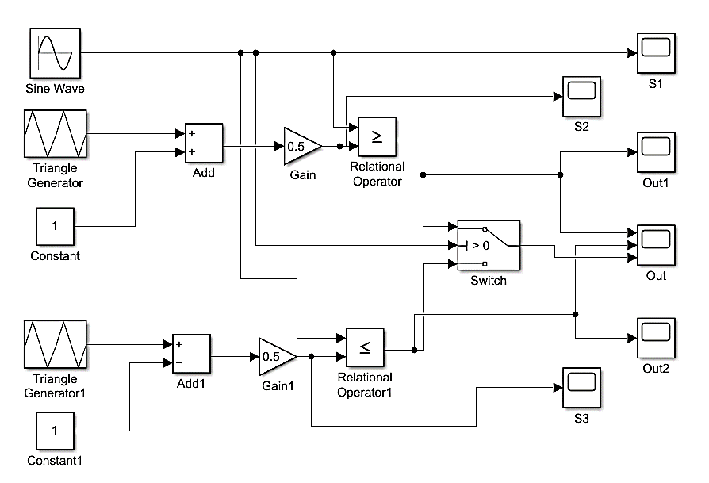

*Fig 1.1: Circuit diagram for the implementation for the given problem*

* 1. **Graph**

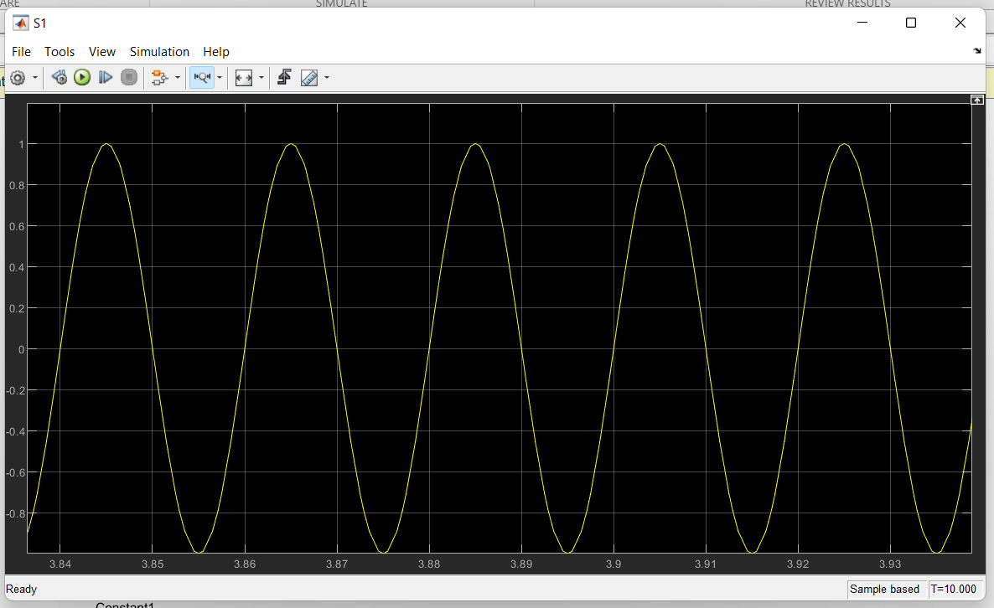

*Fig 1.2: Sine wave signal (S1) (Amplitude = 1, f = 50 Hz)*

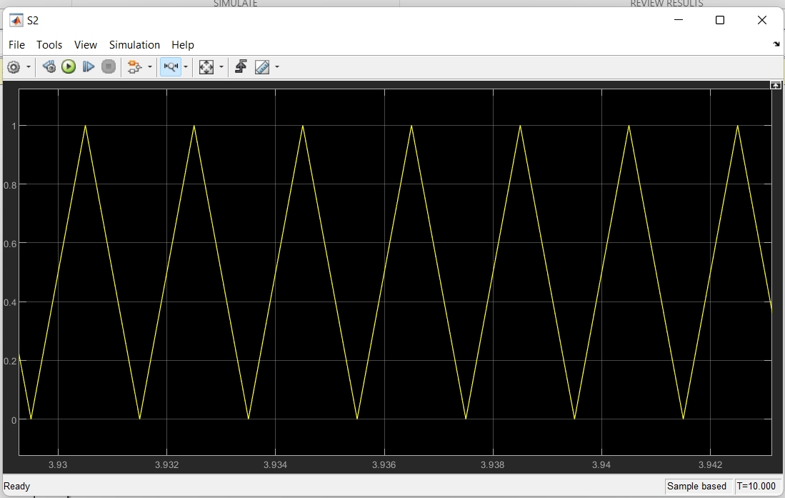

*Fig 1.2: Triangle wave signal (S2); f= 500Hz, Vp-p = 0 to 1*

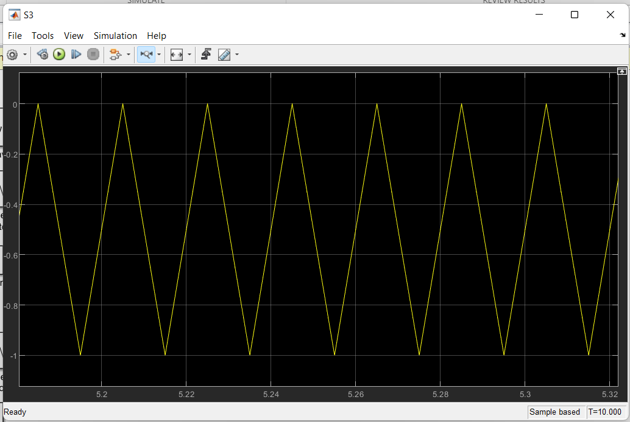

*Fig 1.3: Triangle wave signal (S3); f= 500Hz, Vp-p = -1 to 0*

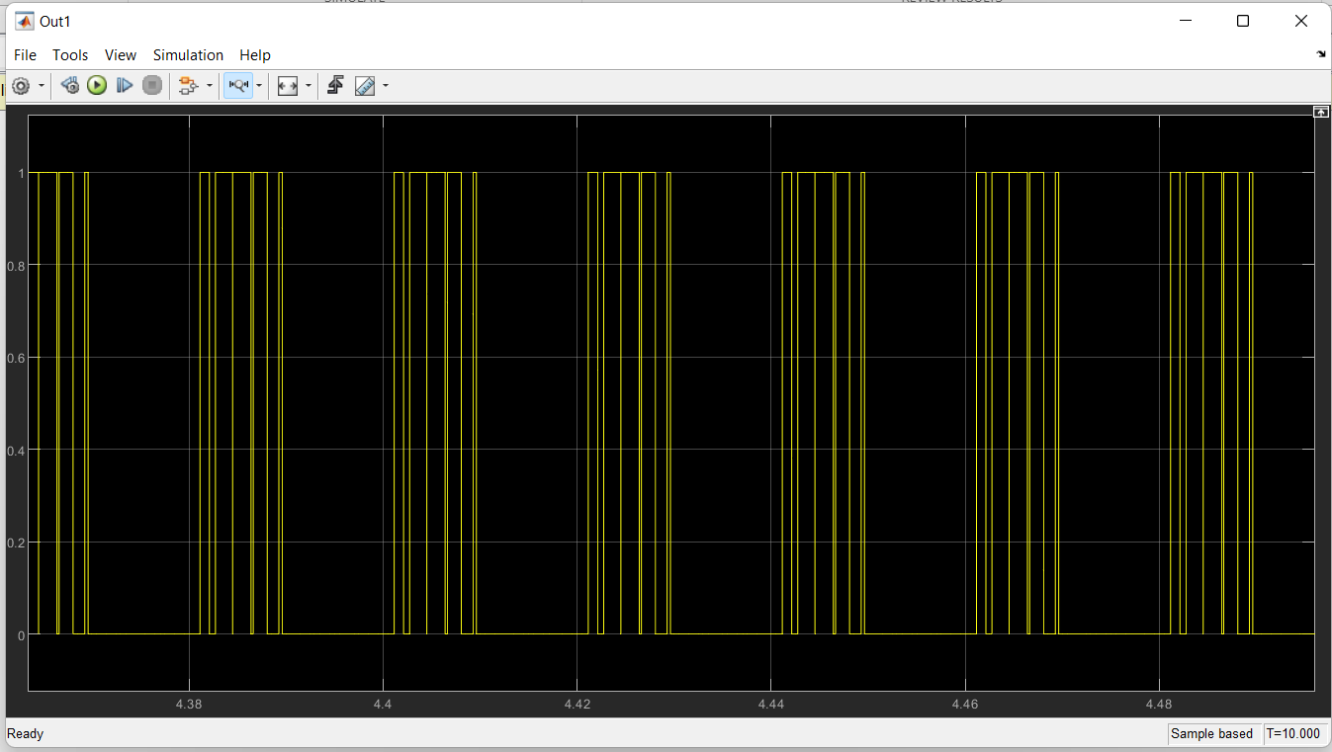

*Fig 1.4: Output 1 wave, where 1 for, S1>=S2 else zero*

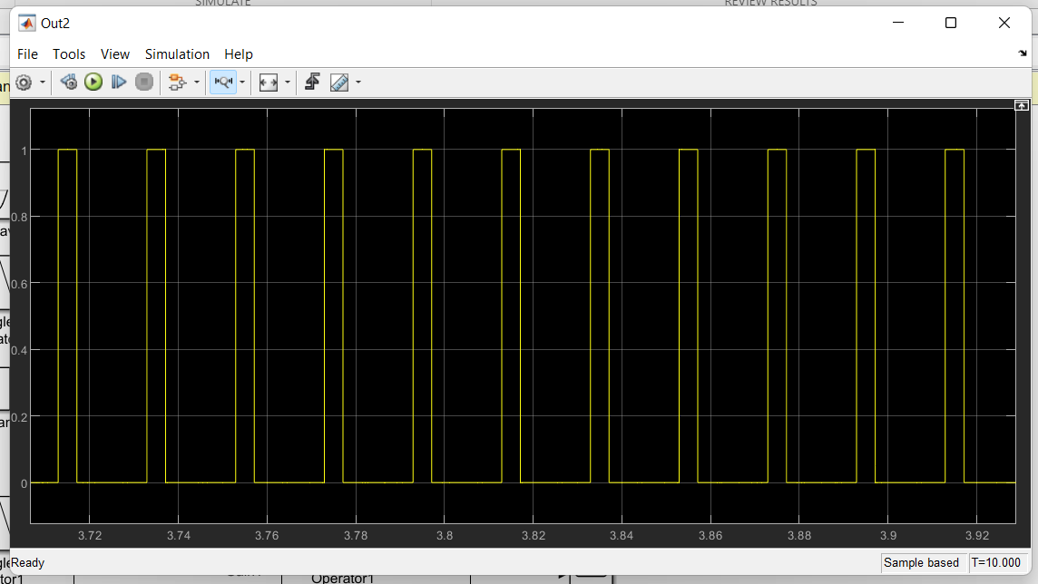

*Fig 1.4: Output 2 wave, where 1 for, S1=<S2 else zero*

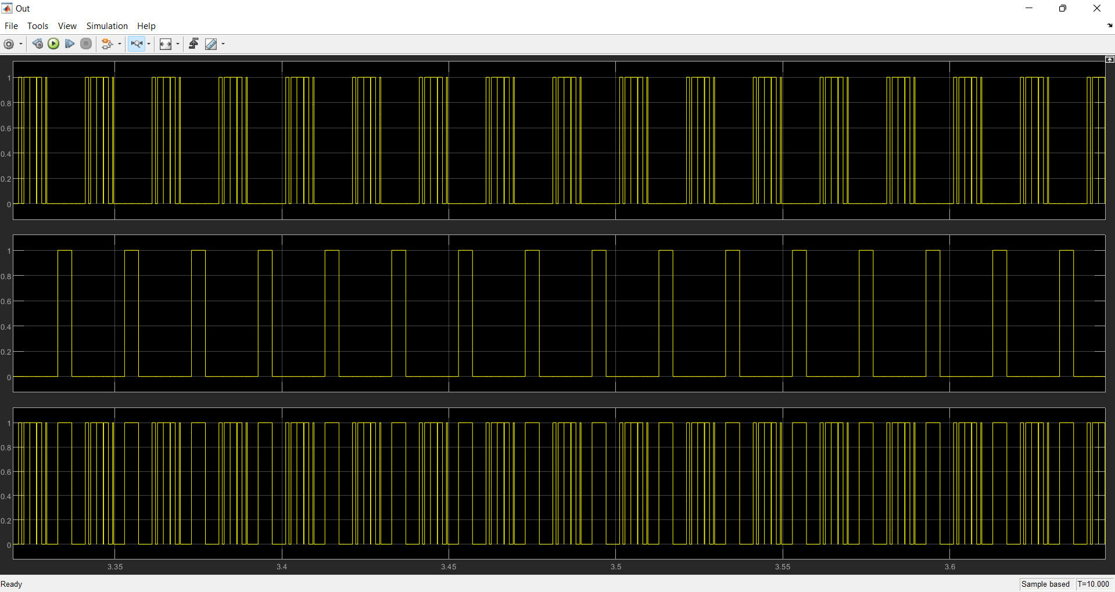

*Fig 1.4: Output wave*

* 1. **Discussion & Conclusion**

MATLAB Simulink is a powerful and flexible computational tool that is used extensively in academia and research worldwide.

This experiment's objective was to learn about Simulink tools, different types of library functions, and how to implement them. To understand its implementation method, a problem was solved. Here a sine wave and two triangular waves were used and compared using library functions. Thus, the final output was obtained and scoped in Simulink. As a result, the experiment is deemed a success.